Challenge #4 – Popsicle Stick Catapult
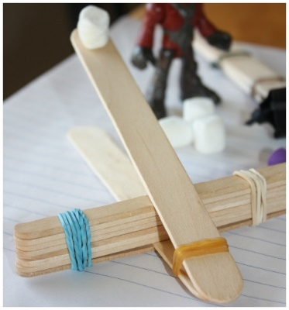
The Challenge:
Design teams (pairs or trios) will build a popsicle stick catapult to launch a marshmallow a specified distance and into a specified location.

Design Challenge Contest: Each design team will have 15 minutes to build a free-standing popsicle stick catapult that will launch a marshmallow to a specified distance and into a specified location. A team’s success will be judged based on the success of 5 launches.

Materials:
- 15 popsicle sticks
- 5 rubber bands
- 12 inches of masking tape
- 1 spoon
- 1 marshmallow
Rules of Engagement:
You can only use the supplies given to you by your instructor. NO additional materials can be added.
Not all the materials have to be used.
The structure must be free-standing. It may not be taped down to the table or propped up.
You will have 15 minutes to construct and test your design before the Challenge.

DUE before and on day of presentation:
- SOA Write-up: Posted format due 24 hours before presentation to instructor as attachment via email.
- Present Design Challenge to the class.
  - As a team, work together to engage the class in the Design Challenge. TEAMWORK: each person will be expected to share equally in the write-up and delivery of presentation.
  - Have all the supplies you need for the class to complete activity (check with instructor).
- Feedback Form
  - Fill out team rubric assessing each member’s contribution to assignment. This is confidential. Hand in to instructor before presentation.
  - Give grading rubric to instructor to assess your presentation and write-up.
Possible Standards (choose 1 standard and develop your SOA write-up)
1. G1. S1. C2. PO4: Record data from guided investigations in an organized and appropriate format (e.g., lab book, log, notebook, chart paper).
2. NGSS: 3-5–ETS1–1: Define a simple design problem reflecting a need or a want that includes specified criteria for success and constraints on materials, time, or cost.
3. NGSS: 3-PS2-1: Plan and construct an investigation to provide evidence of the effects of balanced and unbalanced forces on the motion of an object.
4. NGSS: 3-PS2-2: Make observations and/or measurements of an object’s motion to provide evidence that a pattern can be used to predict future motion.
5. NGSS: MS-PS3-1: Construct and interpret graphical displays of data to describe the relationships of kinetic energy to the mass of an object and to the speed of an object.
6. NGSS: MS-PS3-2: Develop a model to describe that when the arrangement of objects interacting at a distance changes, different amounts of potential energy are stored in the system.

